## 2. (U) Method

(U) In this section, a method of moment’s approach will be used to describe a flat square perfectly conduction plate. An ability to create holes will then be explained. This allows us to modify the geometry to maximize the Radar Cross Section (RCS).

### 2.1 (U) Method of Moments for a Flat Square PEC plate

(U) The method of moment formulation for a flat perfectly conducting square plate is well documented. For convince of the reader, a brief overview is given here, however for a more rigorous explanation please refer to [PETERSON REF].

(U) To begin, we start with the Electric Field Integral (EFIE) equation [EFIE EQ]. Taking the advantage of the square geometry, the plate is broken into equal sized squares of length *a* that will be referred to as cells.

(U) The current is expanded into a series representation using the well-known “roof-top” basis functions [CURRENT EXPANSION EQ] that is centered on the edge between two cells at the point ). To deal with polarization, the current will be split into x-directed and y-directed current. The point’s locations for each polarization are shown in [Jx BASIS FIG] and [Jy BASIS FIG].

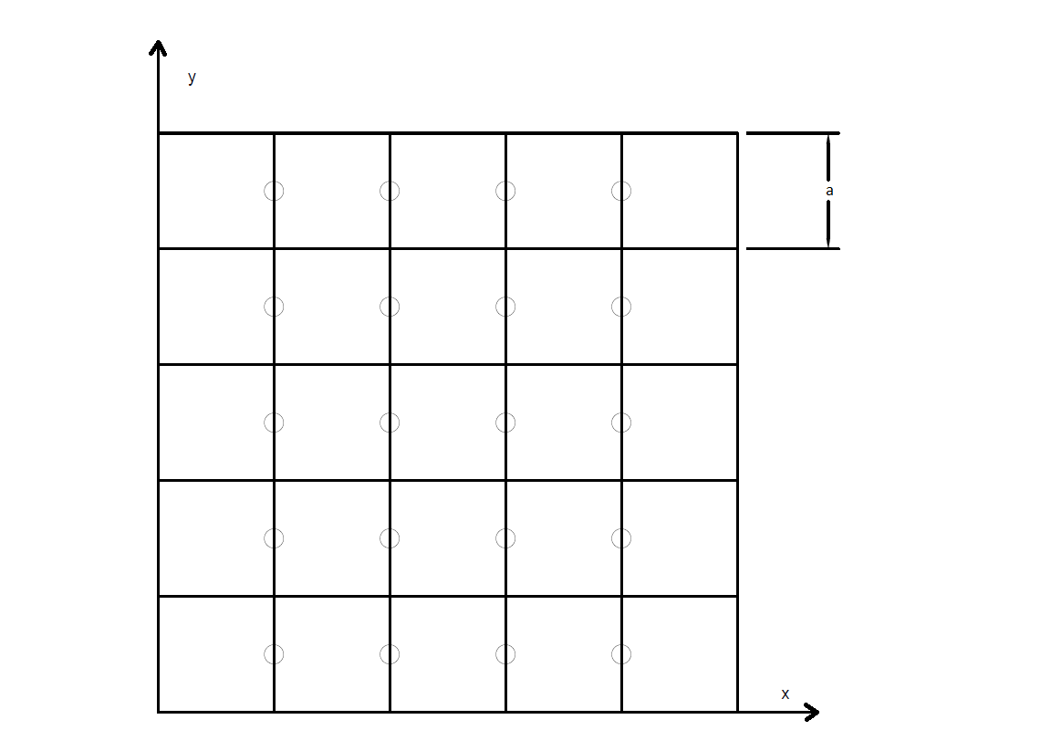

**(U) Figure [Jx BASIS FIG]:** center points defined for a 5x5 cell plate. Circles show the center point of the basis function.

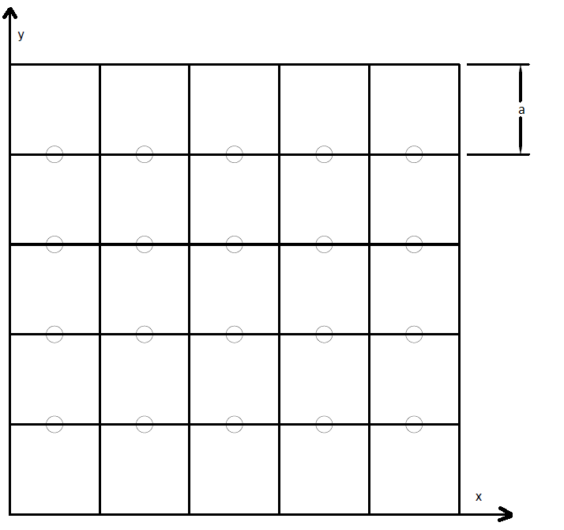

**(U) Figure [Jy BASIS FIG]:** center points defined for a 5x5 cell plate. Circles show the center point of the basis function.

(U) To create the N-equations necessary to solve the now N-unknowns, the expansion is tested with the “razor blade” function defined in [RAZOR BLAD EQ]. Following these calculations will give the impedance matrix and the metal plate is fully described [PETERSON REF].

### 2.2 (U) Creating holes in the plate

(U) Now that the plate has been fully described, we need some way to place holes in it. This allows us to change the geometry in hopes of maximizing the Radar Cross Section (RCS).

(U) To create a hole, all that needs to happen is for a cell to be removed from the plate geometry. To do this, the corresponding edges need to be found and then removed from the impedance matrix. For example, in the above picture to remove the middle cell, the corresponding edges are 3, 4, 9, and 10. This means those edges no longer exist and can not be interacting with any other current on the plate. The impedance matrix needs to be updated to represent this and can be done by removing the third, fourth, ninth, and tenth column and row.

(U) Single cells cannot be considered on their own. This could lead to the case where a single cell is surrounded by holes. This representation implies that current is constant across this area of the plate which is incorrect. Instead, cells are grouped together. This paper will refer to these groupings as pixels. Pixels will then either be “on“ (metal) or “off” (hole)

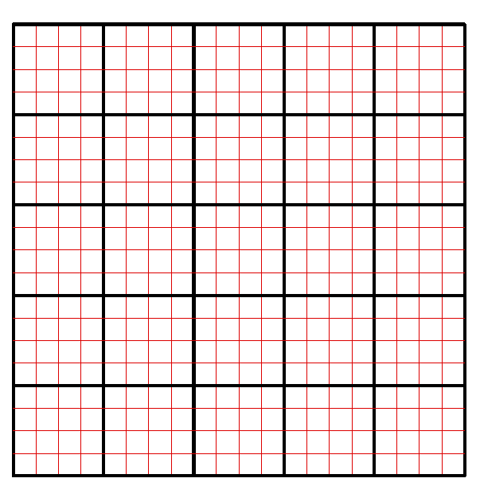

**(U) Figure [PIXAL/CELL FIG]:** A 5x5 pixel plate with 4x4 cells per pixel (20x20 cells total)

(U) One problem found is if two pixels’ corners touch. Other simulation software shows current flow. This formulation in its current form does not allow for this phenomenon. To fix this a single cell can be used to connect the corners.

(U) An example is shown in [PIXEL CORNER FIG] where yellow is metal and . Cell (8,8) is set to be metal. To show the importance of this, the current is generated for 2 inch plate at 8GHz using the 20x20 cell division shown. As seen, a substantial amount of current exist at this corner.

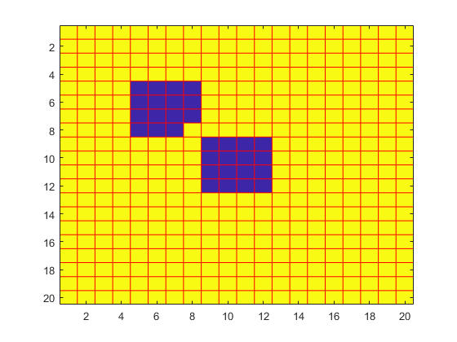

**(U) Figure [PIXEL CORNER FIG]:** An example of the corner fix. Yellow is metal and blue is a hole.

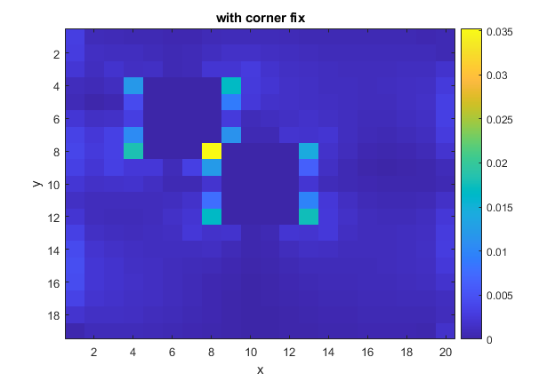

**(U) Figure [CORNER CURRENT FIG]:** current for a 2” plate at 8GHz

### 2.3 (U) Optimization

(U) Matlab’s optimization toolbox was utilized. The code attempts to optimize the average Radar Cross Section (RCS) multiple frequencies, elevation angles and azimuthal angles. Because of symmetry, only angles between zero and must be considered. The system is driven by a plane wave at various incident angles. Both polarization were considered and averaged equally.

(U) We found that pattern search and the genetic algorithm generally returned the same result, but pattern search was faster.

## 3. (U) Results & Discussion

### 3.1 (U) Simple example

(U) Taking previous example above, a 20x20 cell plate with 5 pixels across was optimized first using genetic algorithm and then pattern search. The chaff was illuminated using incident plane wave and divided into twenty discreet points each. The monostatic RCS was sampled at each angle and averaged. The following chaff was generated in 5.096 minutes

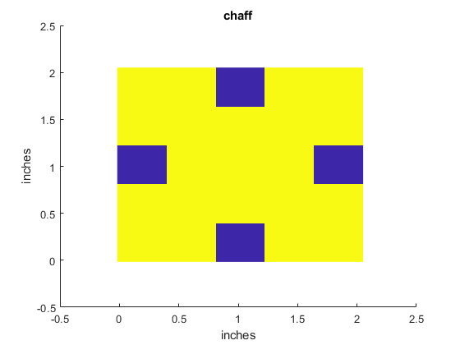

**(U) Figure [SIMPLE CHAFF]:** 20x20 pixel and 5x5 cell generated chaff.

(U) The chaff returned an average monoRCS of 0.0057 m2 as opposed to a metal plate’s 0.004m2, a 17% improvement. For comparison, the monostatic RCS for a \theta polarized incident wave is shown below.

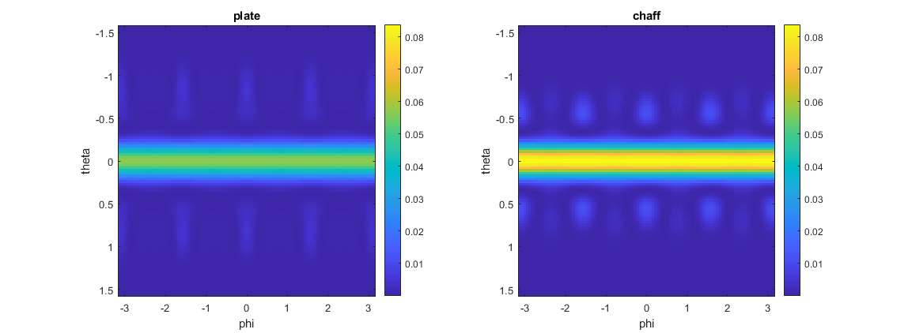

**(U) Figure [SIMPLE CHAFF RCS]:** The generated chaff’s monoRCS (right) as compared to a metal plate (left)

(U) Pattern search was also used and returned the same answer except it only took 29.8 seconds to run.

### 3.2 KA-Band Pattern

(U) A 3mm chaff is next optimized at 35GHz. The plate is divided into 15x15 pixel pattern that contain 4 cells each or 60x60 cells total. The chaff was once again illuminated using incident plane wave and divided into twenty discreet points each. The following chaff pattern was generated.

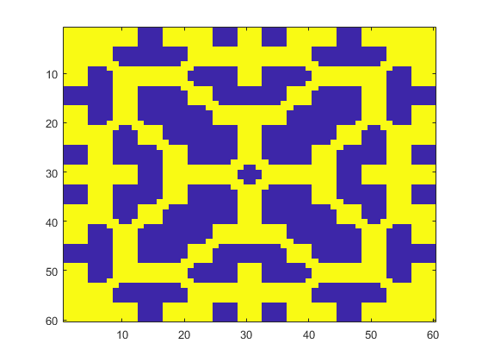

**(U) Figure [KA CHAFF RCS]:** Optimized 3mm Chaff pattern at 35GHz

## 4. (U) Conclusion

A method of moments approach to optimizing chaff pattern has been demonstrated.

## (U) References

1. Peterson, Andrew; Ray, Scott; Mittra, Ray. *Computational Methods for Electromagnetics.* Oxford University Press, 1998